Use Case name: Add New Lecturer to LIT System

Participating Actor: HOD (Head of Department)

Entry conditions:

1. HOD wishes to add a new lecturer into the LIT system.
2. HOD invokes the Add New Lecturer to LIT System function.

Flow of Events:

1. The system displays the Add New Lecture to LIT System screen with a list of labels and fields corresponding to the details that the system requests the HOD to input for the addition of a new lecturer into the LIT system. The requested details include the new lecturers first name, last name, date of birth, address, phone number, email address and the date which the lecturer was hired on and requests the HOD to click ‘Add New Lecturer’.
2. The HOD enters the requested new lecturers first name, last name, date of birth, address, phone number, email address and the date which the lecturer was hired on into the corresponding fields and clicks the ‘Add New Lecturer’.
3. The system displays a confirmation showing the new lecturer and their details (first name, last name, date of birth, address, phone number, email address and the date which the lecturer was hired on) along with a generated employee ID and states that the new lecturer has been added into the LIT system and requests the HOD to click ‘Finish’.
4. The HOD clicks ‘Finish’.

Exit Conditions:

1. The new lecturer is now added the LIT system.

Special Requirements:

1. No special characters are allowed inside the fields, except for the comma symbol inside the new lecturers’ address field.
2. No field should exceed the length of 200 characters.

Use Case Diagram

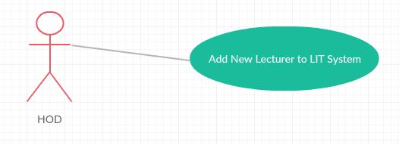

Class Diagram

(Before creation of Sequence diagram)

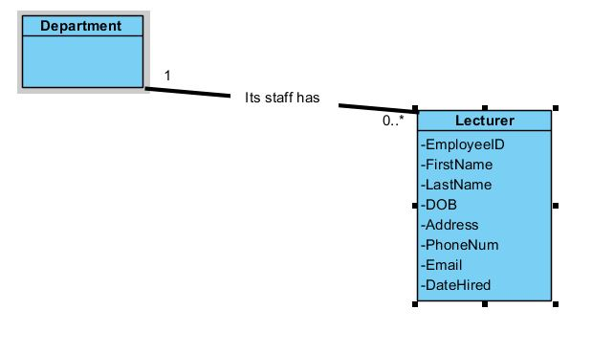

Sequence Diagram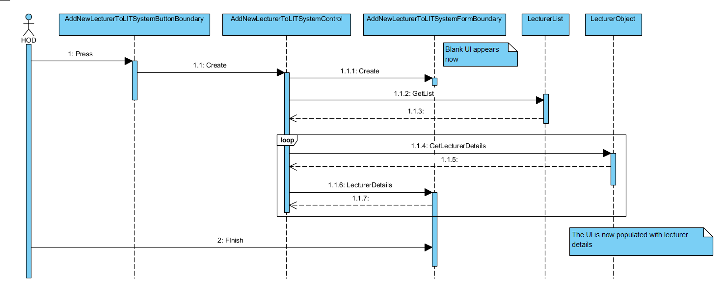

Class Diagram

(After Sequence Diagram Development)

